COMSATS UNIVERSITY ISLAMABAD
DEPARTMENT OF COMPUTER SCIENCE
ApexQC: Interactive Manufacturing Quality Control Visualization System
Lab Terminal Project · Data Visualization Techniques (DSC327)
GitHub Repository: https://github.com/waliurehman/Manufacturing-Quality-Control-
GitHub Pages Live Deployment: https://waliurehman.github.io/Manufacturing-Quality-Control-/
Student Name | Roll Number
Wali Ur Rehman | SP23-BDS-054
Khadija Jumani | SP23-BDS-023
Submitted to: Dr. SHANEELA NAZ
June 19, 2026

1. Project Overview & Objective
ApexQC is a web-based interactive data visualization system built with D3.js for manufacturing quality control analytics. The application operates on the Manufacturing QC Dataset which details 5,000 production runs across three key Pakistani industrial sites: Lahore, Islamabad, and Karachi. The portal offers operations managers, process engineers, and quality assurance supervisors real-time interactive insights into yield rates, defects, downtime, and parameter anomalies.
Mapped Course Learning Outcome: Develop a web-based system using interactive visualization techniques and libraries (D3.js). This project implements four distinct, interconnected interactive visualizations that align with Bloom's Taxonomy 'Creating' level to enable exploration, filtering, temporal inspection, and parameter correlation.
2. Dataset Overview & Characteristics
The dataset comprises 5,000 records of individual machine manufacturing runs from January 2023 to December 2024. The data was processed from the Excel format (Manufacturing_QC_Data.xlsx) into CSV for client-side streaming.
2.1 Schema Description
Column Name | Type | Description
Date | Date (YYYY-MM-DD) | Production run calendar date
Factory | String | Manufacturing plant (Lahore, Islamabad, Karachi)
Machine_ID | String | Machine identifier (M-101 to M-105)
Product_Type | String | Product type manufactured (Engine Parts, Brake Disc, Gear Box, etc.)
Units_Produced | Integer | Total units fabricated during the run
Defective_Units | Integer | Total units failing quality standard checks
Defect_Type | String | Primary failure category (Material Defect, Surface Crack, etc.)
Efficiency_% | Float (%) | Machine output rate divided by standard capacity
3. Data Preprocessing & client-side parsing
Excel parsing is computationally expensive and slow to run natively in browser sandboxes. To solve this, the source Excel sheet was converted to a flat CSV file, which reduces loading latency. Preprocessing steps are as follows:
Casting & Normalization: Numeric fields such as units produced, defective units, defect rates, cost, and efficiency are cast into floats/integers. Missing value entries are default-initialized to prevent drawing bugs in D3.
Temporal Formatting: Raw dates are parsed into JavaScript Date objects to facilitate time-scale mapping. Month ordering lists are created to map month names to chronological sorting order.
Aggregation Matrices: Dynamic grouping maps are created via D3.group and D3.rollup by Factory, Product, and Machine to enable fast O(1) query lookups when interactive selectors are clicked.
4. Exploratory Data Analysis (EDA) Findings
Exploratory analysis reveals several critical operational bottlenecks that the visualizations communicate:
Factory Performance: The Karachi plant produces the most units (465,947) but also suffers from the highest average defect rate (7.96%), representing a significant financial loss. Islamabad and Lahore have stable defect rates of 7.56% and 7.70% respectively.
Machine Outlier Detection: Machine M-103 stands out as a major outlier. Across all factories, M-103 has an average defect rate of 17.74% and a low efficiency of 74.46%, compared to M-101 and M-105 which maintain defect rates below 5% and efficiency above 85%. This indicates that M-103 requires immediate maintenance.
Shift Downtime Anomalies: Operational logs show that Night shift runs experience an average downtime of 55.59 minutes. This is more than double the Morning shift (17.59m) and Evening shift (27.29m).
Product Quality Rankings: Engine Part B (8.35% defect rate) and Transmission Kit (8.22%) are the hardest components to manufacture cleanly, while Brake Disc (7.45%) and Gear Box (7.42%) show the best quality control yields.
5. Visualizations: Choices and Justification
The system implements four dynamic charts to answer operational questions, adhering to Tufte's principles of graphical integrity:
5.1 Factory yield & Defect Donut: Answers 'What is the yield rate and what are the primary failure categories?' Uses structural text blocks for high-priority numbers and a D3 Donut Chart for proportions. Donut charts utilize angle and arc length to represent categories, which is highly effective for displaying a small set of components (4 defect types).
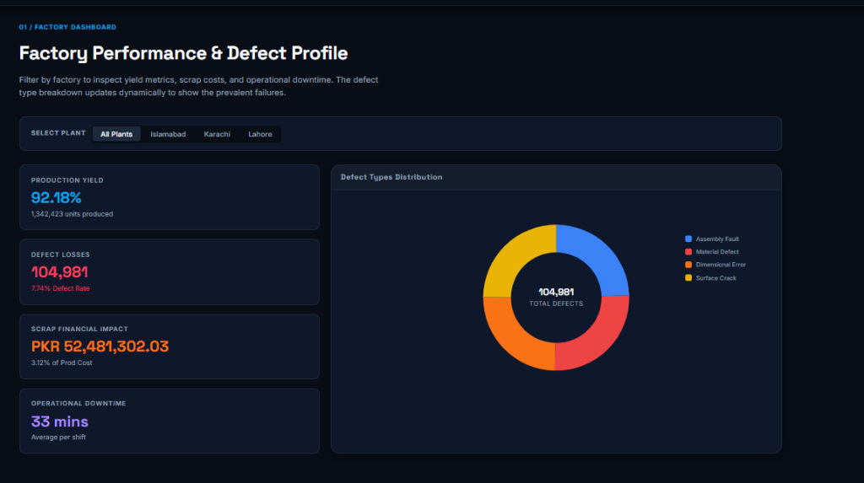
Figure 1: ApexQC Factory Profile & Defect Types Distribution Donut Chart
5.2 Performance rankings & Machine comparison: Answers 'Which products fail most and how do machine capacities compare?' Uses horizontal bars for products because the Y-axis names (e.g., 'Transmission Kit') read naturally horizontally. Uses grouped vertical bars for machines to compare Efficiency (green) and Defect Rate (red) side-by-side on dual y-axes.
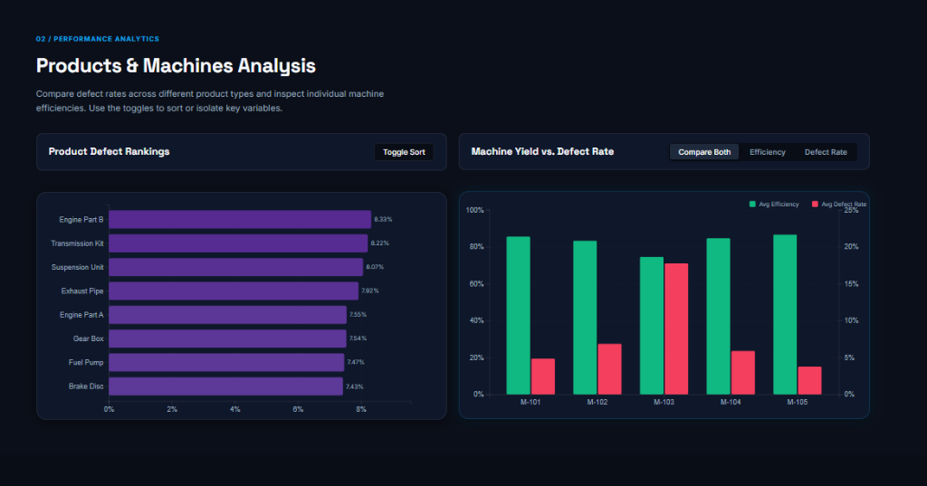
Figure 2: ApexQC Product Defect Rankings and Machine Performance Comparison
5.3 Temporal line trends with Brush Zoom: Answers 'Has the defect rate decreased over time?' Uses a dual line chart mapping month to X and rate/efficiency to Y. Line marks represent continuous change over time. Incorporates a Brush-Zoom mini timeline below the main chart to allow zooming in on specific months.
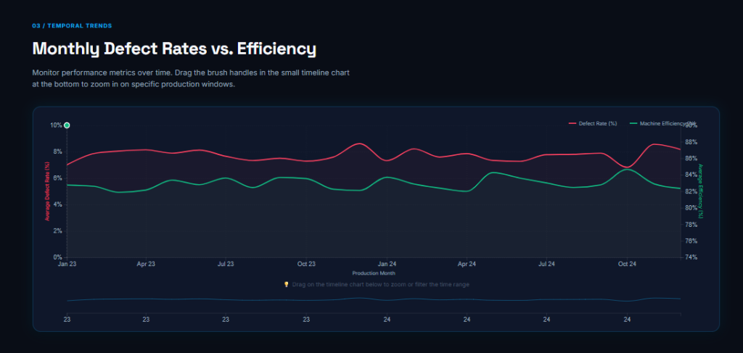
Figure 3: ApexQC Temporal Quality Control Trends with Interactive Brush-Zoom Timeline
5.4 Process Parameter Scatter Correlations: Answers 'Do high temperatures or pressures cause defects?' Uses a Scatter Plot mapping temperature to X and efficiency/defect to Y, color-coded by Shift (Morning/Evening/Night). Scatter plots are the most effective visual channel for mapping correlations between two continuous variables.
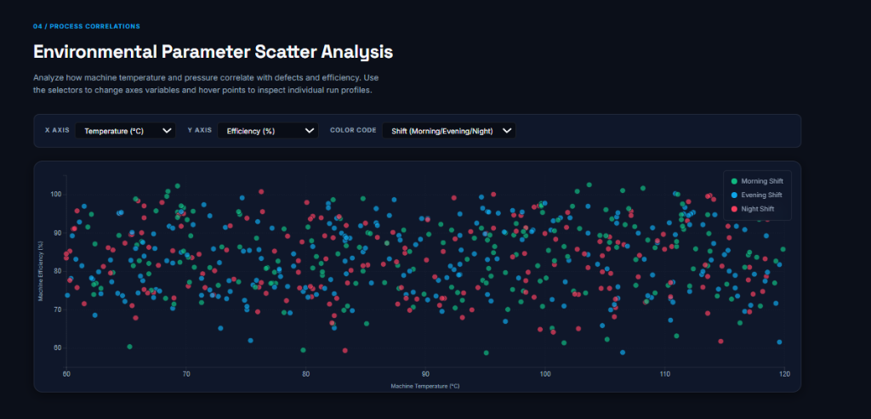
Figure 4: ApexQC Process Parameters Scatter Analysis (Temperature vs. Efficiency by Shift)
6. Interactive Features & Interface Flow
The interface implements dynamic interaction pathways to reduce cognitive load:
Dynamic Filtering: Clicking Lahore, Karachi, or Islamabad updates the KPI stats and transition-animates the donut chart to reflect that factory's defect breakdown.
Details-on-Demand Tooltips: Hovering over donut slices, bars, timeline points, or scatter dots opens a global tooltip showing exact data counts and ratios.
Brush Zooming: Users can drag the handles of the bottom mini timeline to dynamically filter the time range of the main line chart.
Variable Toggles: Dropdown selectors in the scatter plot section allow users to map different axes variables (Temperature, Pressure, Produced, Downtime) to explore process boundaries.
7. Design Decisions & System Aesthetics
To deliver a premium visual experience, the interface uses a dark industrial palette: Slate dark gray base (#090d16) and Slate Blue panels (#0f172a). Accent colors are chosen semantically: green (#10b981) for efficiency and good yields, red (#f43f5e) for defects, and orange (#f97316) for downtime. This provides high contrast and reduces eye strain. Font pairings use Space Grotesk for crisp headings and Inter for tabular text data, creating a clean modern look.
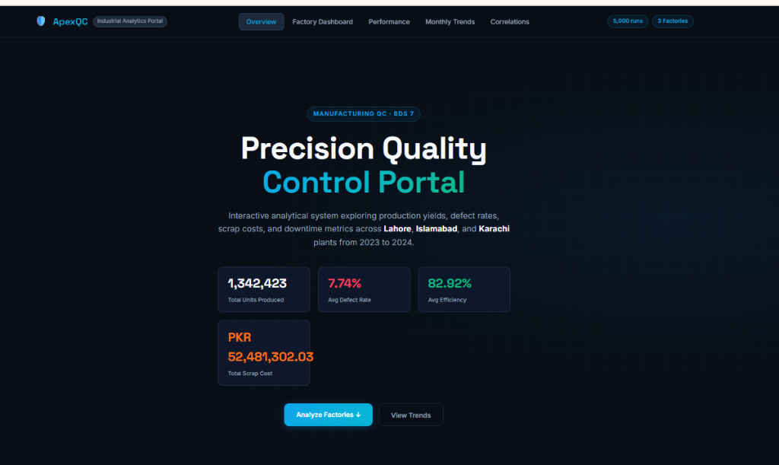
Figure 5: ApexQC Precision Quality Control Portal Overview & Key Performance Indicators (KPIs)
Graphical Integrity: Adheres to graphical integrity: Y-axes begin at zero (or an explicit baseline for efficiency), missing data is handled safely, and scales span the actual observed values.
8. Conclusion
The ApexQC dashboard delivers a complete, interactive, web-based visualization system that successfully answers key quality control questions. By utilizing advanced D3.js components like donut charts, grouped comparative bars, timeline brush zooms, and dynamic parameter scatter plots, the system provides a robust analytics tool that satisfies the BDS 7 semester project criteria.

